Poor Concentration
Healthy Young Minds Newsletter
Parents Tips

TH

CAMHS would be very grateful for feedback https://www.surveymonkey.co.uk/r/XBY2JPR

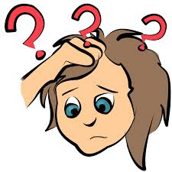

How would I recognise if my child
has poor concentration

- Your child may often seem not to be listening to you
- They may have difficulty following instructions
- May struggle to complete their homework
- Cannot focus on activities that take too long to complete and may start misbehaving
- Gets frustrated easily
- Gets bored easily
- Flits from one activity to another

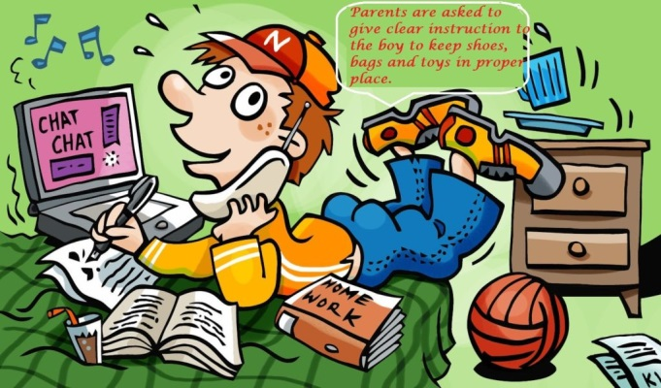

What can I do to help a young person with poor concentration?

- Get the child’s attention when giving an instruction by saying their name first

- Chunk instructions giving them 1 or 2 at a time and get them to repeat them back

- Gear activities to your child’s attention span; play buckaroo rather than monopoly, if they can manage one game of bowling don’t book two.

- Use visual aids, time tables and written instructions to remind them what is expected of them

- Give the child a role of responsibility during family activities to help keep them
Focussed

- Card games such as the pairs games increasing the number of pairs can help increase concentration skills or Kim’s game with objects to remember on a tray and increasing the number of objects

- Try and stay calm when your child seems to be not listening or doesn’t do as their told, getting stressed will make their concentration worse not better

- To help them with homework find an area away from distracting stimuli

- Agree how long they can work on a task then use a clock for them to work to

