HYPERACTIVITY
Healthy Young Minds Newsletter
Tips for Parents

TH

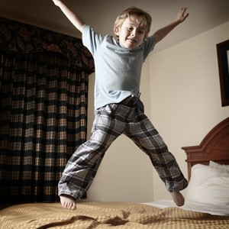

What is Hyperactivity?

- A word we use to describe excessive activity.
- An inability to keep still for long periods

What signs should I look out for in a young person?

- Activity levels higher than other children of a similar age
- Always full of energy
- Difficulties sleeping
- Early wakening
- Restlessness
- Difficulties concentrating on homework
- Difficulties managing the school day
- Fidgety
- Fiddling
- Leg swinging or feet tapping

CAMHS would be very grateful for any feedback on this newsletter. Please could you complete https://www.surveymonkey.co.uk/r/XBY2JPR
te the online survey:

What can I do to help a young person with hyperactivity?

- Provide physical activities for the child to engage in such as swimming, walking, trampolining. Set mini challenges (timing how long it takes to run around the block)
- Allow opportunites for movement with responsible tasks such as laying the table when you are preparing meals , helping to serve food, prepare peoples drinks, feeding the pets. Having their own roles and responsibilities will help feelings of belonging and self worth as well
- Be flexible, allow the child to stand up or kneel on their chair if it helps them finish their meal at the table
- Prepare them in advance of changes and explain what is going to happen and why
- Regular routines around bedtime and getting ready for school
- Relaxation exercises before bedtime
- Provide acceptable (quiet) activities for ‘early risers’
- Support your child to find activities that help them to be calm and restful so they can learn what helps them feel calm when feeling stressed: such as listening to music, having a hot bath
- Teach your child respect for peoples personal space and to keep hands and feet to themselves (imagine an invisible hula hoop)
- Sew a label with a couple of shaped buttons on in their school pocket to fiddle with
- Avoid over relying on electronic devices to keep them calm and focussed

