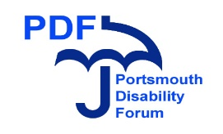 Parent Remuneration Disclosure Form 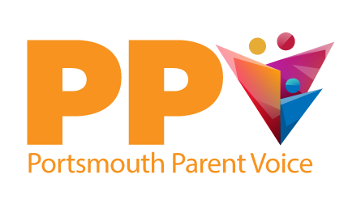

Portsmouth Parent Voice would like to make you aware that if you are in receipt of any benefits (including Housing Benefit), it is your responsibility to inform the officers or service concerned of any remuneration payments that you receive from Portsmouth Parent Voice. If you find that any payment from us may affect your benefit payments and would rather not accept it, you are entitled to donate the money to Portsmouth Parent Voice.

Please read and sign below to confirm that you understand the conditions of the remuneration policy in line with benefit entitlements. Portsmouth Parent Voice cannot accept any responsibility for any charges incurred.

I confirm that I understand the above information;
Name (please print): ………………………………………………………………………………………………………………………
Contact email address or telephone number: …………………………………………………………………………………
Signed: …………………………………………………………………………………………………………………………………………….
Date: ………………………………………………………………………………………………………………………………………………..

Thank you for your co-operation in completing this form.

