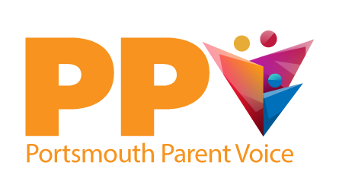

PARENT REPRESENTATIVE REGISTRATION FORM
About you
Name:
Address:

Telephone: Email:
What aspect of PPV would you like to be involved in (please circle)?
Steering Group Strategic meetings Volunteering

About your child

Nature of child’s disability/special need:

Does your child have an EHCP? Yes No

Is your child on SEN Support? Yes No

How old is your child?
Is he/she in mainstream or special needs school, primary, secondary, college, employment or training (please circle), other please state:
Date completed:

